**Team 808**



Fall 2022

# 

# **1 Revision history for this document**

| **Version Number** | **Version Date** | **Revision Description** |
| --- | --- | --- |
| 0.1 | 9/8/2022 | First draft, sections 1-2.2.5 added. |
| 0.2 | 10/7/2022 | Section 3 added, changes made to project scope after advisor meetings. Formatting fixed. |
| 0.3 | 11/2/2022 | Section 5 added. |
| 0.4 | 11/10/2022 | Sections 4, 7, and 8 added. Sections 2 and 3 revised, changes reflect design constraints. Formatting fixed. |
| 0.5 | 12/9/2022 | Added sections 6, 3.4, 3.6, and 4.6, and updated existing sections to reflect the project scope. Updated hardware, budget, and risk demos. |
| 0.6 | 2/28/2023 | Added _. Updated sections _ to _. Updated budget. |

# 

# **2** **Product Overview**

## **2.1** **Project info**

### **2.1.1** **Project title**

Scalable Electrosurgical Unit for Controlling and Powering the Ligasure Dissection Device

### **2.1.2** **Product title**

Electrosurgical Unit System

### **2.1.3** **Sponsor**

Medtronic

### **2.1.4** **Technical advisor**

Keith Malang

### **2.1.5** **Your supervisor**

Gabe Altman

### **2.1.6** **Team name**

808

### 

### **2.1.7** **Team members, roles, responsibilities**

**Sonal Tamrakar Team Lead/PCB Design Specialist**

-Manages team responsibilities and roles

-Lead PCB design by using Altium and other resources

-Makes final decisions if there is uncertainty

**Rustin Chang Hardware Lead**

-Leads hardware efforts, integrates whole design

-Debug/Test/Troubleshoot Hardware issues that arise

-Runs simulations/CAD/hardware development applications

**Ali Moran Product Manual Editor**

-Ensures consistent style and format throughout PM

-Updates PM revision history as others make changes

-Edit PM for clarity and spelling

-Reminds team members to make use of PM for documenting the design process

**Chengming Li Software Lead**

-Software development

-Holds all repositories for code using GitHub

-Software architecture design

**Daniel Chun Financial Manager/Morale Manager**

-Bookkeeper of all costs spent on the project

-Record all costs spent on non-project-related activities involving the capstone group

-Will conduct weekly team-member check-ins to see if anyone has any pressing needs/scheduling issues to adjust workload if needed

**Noah Zhao Communications Manager**

-In charge of communication with our sponsor and organizing meetings

-Responsible for communicating immediate updates and needs to TA mentor

**2.2** **Elevator pitch**

An electrosurgical device, or ESU, is a surgical incision device used to incise and remove organic tissue efficiently while controlling bleeding. As it currently stands, ESUs are inaccessible to many parts of the world due to their power generator’s steep cost and large size. Our product is a smaller, less expensive ESU, a complete system with a generator, which runs off of an AC wall connection. A portable, relatively cheap generator that connects to pre-existing Ligasure devices reliably provides the electrical signals and control functions required by the ESUs, which along with a clear guided user interface makes this ESU system accessible to medical professionals worldwide.

## **2.3 The problem your product solves**

### **2.3.1** **The Big Picture**

There is much disparity between the medical technology that different countries have access to. People everywhere deserve the best healthcare available, and this technology gap is preventing that. In order to rectify this, relevant tech must be made accessible to countries that cannot afford the high prices of current equipment through alternatives. Having different operating room setups which may not integrate technology from different parts of the world smoothly is another problem which must be addressed, and could be solved with tech alternatives.

### **2.3.2** **How your product fits into this overall solution**

Developing countries do not have access to the same medical technology which is saving lives in other parts of the world. To rectify a part of this issue, the ESU’s generator acts as a replacement for the expensive, bulky generators currently in use.

### **2.3.3** **Your vision of what your product will do when you are done**

The ESU is a scalable small form factor generator that drives an existing LigaSure device from Medtronic. The generator is powered by an AC wall socket, and, as a tabletop device, can rest on either a fixed table or a small rolling table as applicable to operating theater requirements. The generator is composed of a controlling processor which generates a fixed 431KHz RF tone delivering 50 Watts. This generator produces a peak voltage of 115 Volts and a peak current of 3-4 Amps. Using current and voltage sensors, the ESU measures the current and voltage to get the impedance of the tissue in order to monitor change in impedance over a cauterization cycle. The data taken by the sensors will output to a Python-based GUI on a user's computer, and the chassis has built in buttons for power and emergency stop. Compared to the larger generators already developed by Medtronic, this ESU is more accessible to third-world countries in order to provide access to LigaSure technology in hospitals around the globe.

### **2.3.4** **Who is the customer**

The sponsor for the ESU generator is Medtronic, but the users are medical professionals worldwide, with a focus on those from developing countries. Due to cultural and language barriers, the generator has a very simple user interface with clear tones delineating the start/stop of a cycle, an error tone, and a power button labeled with an image instead of words. The GUI is similarly simple, and while it needs to use English words they are all basic and relatively easy to parse.

### **2.3.5** **What are a few of the killer apps**

The ESU device can efficiently transect tissue while also sealing blood vessels, preventing blood loss and circumventing the need for other vessel sealing methods that carry higher risks of infection and insertion of foreign bodies within the patient. It allows for fast, clean tissue and organ removal. The generator required to power this device is smaller than pre-existing ones to be less of an obstruction in the operating theater. The size, coupled with its light weight makes it portable, allowing for easy shipment and transfer between hospitals and other necessary locations. It is cheaper than other existing generators currently in use.

# 

# **3 Requirements**

## **3.1 Marketing requirements**

| **Number** | **Marketing Requirements from Customer** | **Importance Rating: High, Medium, Low** | **Acceptance notes** |
| --- | --- | --- | --- |
| 1 | Small Form Factor (6x12 inches) | High | Three target customers should place the unit within their surgery rooms to see if the size of the unit is acceptable. |
| 2 | Delivers 50 Watts of RF power (431 kHz) to drive a Ligasure device. | High | Measure RF power draw using an oscilloscope to ensure the 50 Watts of power is being delivered at 431 kHz |
| 3 | The waveform delivered by the ESU must be changed accordingly based on the rate of change of the tissue impedance. | High | A cauterization cycle output from the Ligasure results in the successful tissue cauterization |
| 4 | Delivers ‘success’ and ‘failure’ tones after a cauterization cycle output. | Medium | Based on the impedance of the tissue (indicating tissue cauterization state), after a cauterization cycle, we must deliver the correct tone |
| 5 | Provides live data stream from current and voltage sensors located at the jaw of Ligasure device | High | Provide the user with impedance, voltage, and current measurements for debugging. |

## 

## **3.2 Who are the intended end users and how will they use the product?**

The intended end users are medical professionals in low/middle income countries performing surgery on patients. The surgeon can plug in whichever Ligasure device they need to use for a given procedure into the generator, the device starts up, and then outputs to a screen whether or not it’s ready to cauterize. Once ready, the surgeon begins to cauterize tissue, and the device either outputs a completion sound or an error sound based on the impedance measurements taken during the procedure.

## **3.3 Use cases**

The user plugs the generator into a wall and their computer and turns it on with a button. The generator powers up and the user plugs in the Ligasure device. The generator then reads which Ligasure device is in use, as they require different power outputs depending on their size, and it then starts to supply power to the Ligasure device. Once ready to begin a cauterization cycle, the generator outputs onto the computer screen an image telling the user to begin, as well as a specific tone indicating readiness. The user can then proceed with the cycle, cutting and cauterizing the tissue. While the cycle is underway, the device repeatedly samples the voltage and current across the load to calculate impedance allowing it to monitor how impedance changes. Based on the change in impedance, the system will know if the cycle is complete or if there was an error. The impedance, along with the voltage and current measurements, will be fed into the computer where the user may choose to generate a spreadsheet and/or a graph of the data. If an issue does occur during operation, an error sound will play out of a speaker, indicating that a concerning measurement has been taken and the process has halted. If no error occurs and the cauterization cycle completes, the device no longer receives power and outputs a sound indicating successful completion. At this point, the user will unplug the Ligasure device and dispose of it as directed. After all processes are complete the user can then turn off the generator and move it back to storage.

## **3.4 Safety Concerns**

When live, the ligature device will be pushing 50 W of power through its jaws. If handled incorrectly, this could cause very serious injury. Another concern is if a cauterization cycle completes and the generator fails to cease power output for any reason, the patient could receive charring or other burns when the device is removed. Similarly, if the microcontroller receives impedance data from the sensors which indicates a failure in the cycle and does not cut power and indicate to the user that something has gone wrong, the patient could be damaged.

## 

## **3.5 Engineering requirements**

| **Number corresponding to Marketing Requirements** | **What must be done** | **Explanation** | **Acceptance Notes** |
| --- | --- | --- | --- |
| 4 | - We will have to construct both current and voltage sensors on the jaw of the Ligasure device measuring the impedance of the tissue.  - This data feedback from the Ligasure device to our ESU must be digitized using a TI Piccolo  -Data are sampled at least 300M samples/ second | - The current and voltage sensors will allow for easy access to verify the measurements of the impedance for debug purposes and the jaws of the LigaSure device will be the closest contact to the tissue  - The TI Piccolo family provides fast A/D rate allowing the rate of of 8 samples per cycle | -Compare impedance values from the current and voltage sources with known impedance values of tissue |
| 3, 2 | The ESU is composed mainly of a controlling Processor  - Will generate a fixed 431 kHz RF Tone delivering at most maybe 50 watts  - Peak Voltages of the order of 115 V, and Peak Currents of the order of 3-4 A.  - Converts DC to AC Power Inverter (Phase Shifted Full Bridge Topology) | - 50 Watts is required for 5mm tissue incision  - 50 Watts of power is designed for smaller Ligasure devices meaning lower cost for the Ligasure device itself and a smaller ESU to drive the device. | -Measure the RF tone signals and delivered power using an oscilloscope |
| 6 | - Output this data on a python-based GUI | - A user interface with ease of use and simple features are desired to enable medical experts to analyze the cauterization data firsthand and real-time | - Compare our data with an existing Medtronic device to ensure our device is producing reliable information |
| 5 | - Integrate speaker into the system to deliver tones | - Ensures medical room operators are notified of a successful cauterization of tissue | - After a cauterization cycle, verify that our tones correspond to a successful or failed pork tissue cauterization |

## **3.6 Minimum Viable Requirement**

At the minimum, our product (the ESU generator) must be able to complete the system consisting of the generator itself in connection with a wall socket, a ligature device, and a computer. The generator must provide the necessary 50 W of power to the ligature clamps via a functioning system which includes the DC power supply, phase shifted full bridge, and the RF tank + filtering circuit. The DC power supply must feed into the full bridge, which outputs a square wave into the RF tank, which delivers the final sinusoidal wave to the ligature device. The voltage and current sensors in the system must also be working, and both successfully feed their data as an impedance measurement into the microcontroller and Python GUI on the connected computer for user viewing.

# **4 Product Design**

## **4.1 System Diagram**

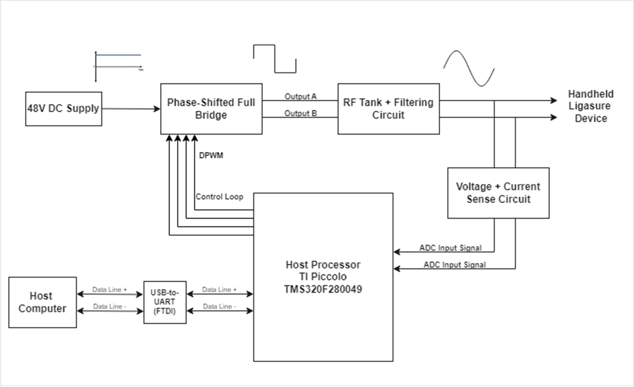

## **4.2 Technology**

**Hardware:**

* Microcontroller: TI Piccolo 280049C
* MOSFETs: TK3R2E06PL
* Gate Drivers: LM5101AMR/NOPB
* Wall power converter: SoulBay 3V - 12V AC wall adapter
* DROK 48V DC power supply
* LigaSure surgical ligature device
* Level-shifting opamp: TLV272

**Software:**

* TMS320F280049C
  + Development board for testing code
* 3 12 bit ADC
  + 3.45-MSPS
  + 8 samples/cycle
  + 1. Voltage sensor
  + 2. Current Sensor
* 3 PWMs
  + Run at 431.25 Khz
  + 1. PWM 5A and 5B, 0 phase degree
  + 2. PWM 6A and 6B, 180 phase shift degree, based on PWM5A and 5B
  + 3. PWM 4A and 4B, stay HIGH
* UART
  + control the PWM on/off and phase shift
* Control Law Accelerator (CLA), second CPU on chip
  + Executes code independently of main CPU
  + ADC and PWM will run in this core
* Direct Memory Access (DMA)
  + Retrieve ADC data from the RAM
* Putty
  + Serial Port
* GUI (Python)
  + Display the real time data (Power and Impedance)

## **4.3 Initial Schematics/Diagrams**

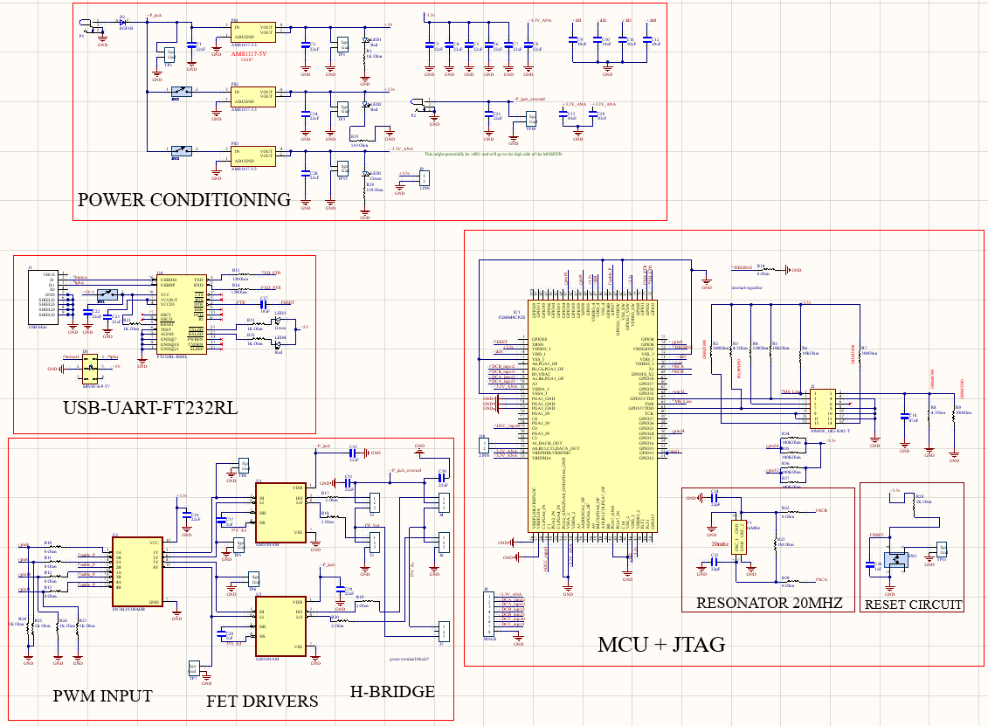

**Figure:** Custom MCU evaluation board with added features such as the FET drivers + FETs

## **4.4 Phase 1 Design & Proof of Concept Results**

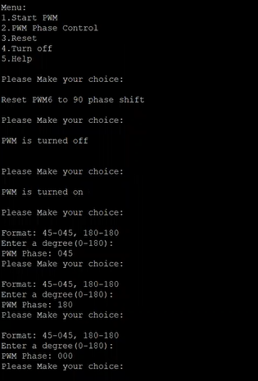

**Figure 1**: PWM phase control displayed in Putty

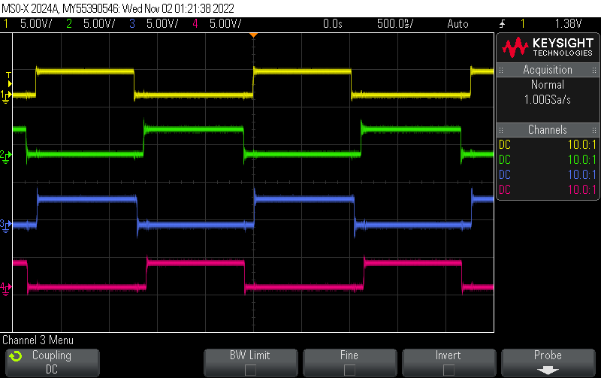

**Figure 2:** Four PWM signals generated from custom PCB with appropriate deadtimes

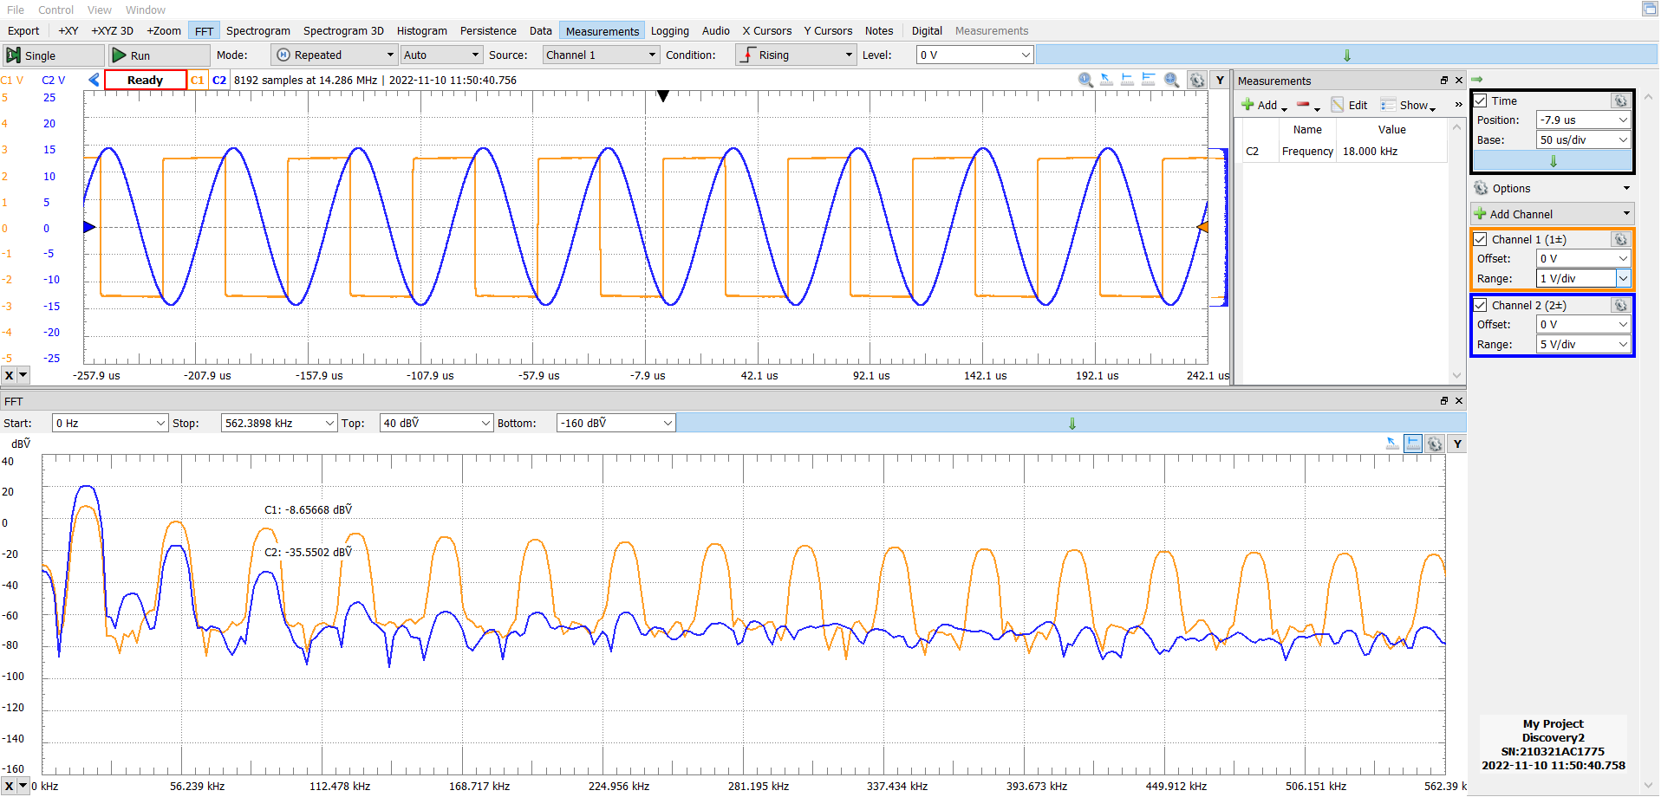

**Figure 3**: Resonant tank measurements on Analog Discovery 2 (implemented on SBB)

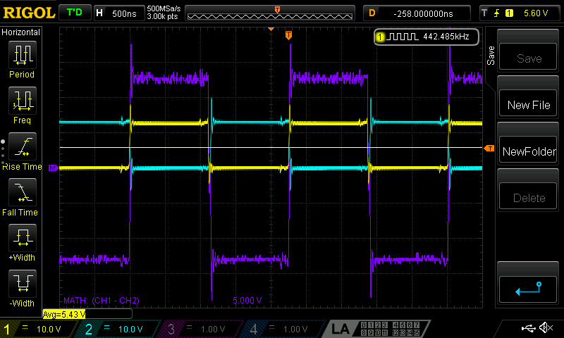

**Figure 4:** Output from the phase-shifted full bridge (in purple), which is the difference between the yellow and the light blue trace using the math function on the scope. The measurements are generated from the custom PCB.

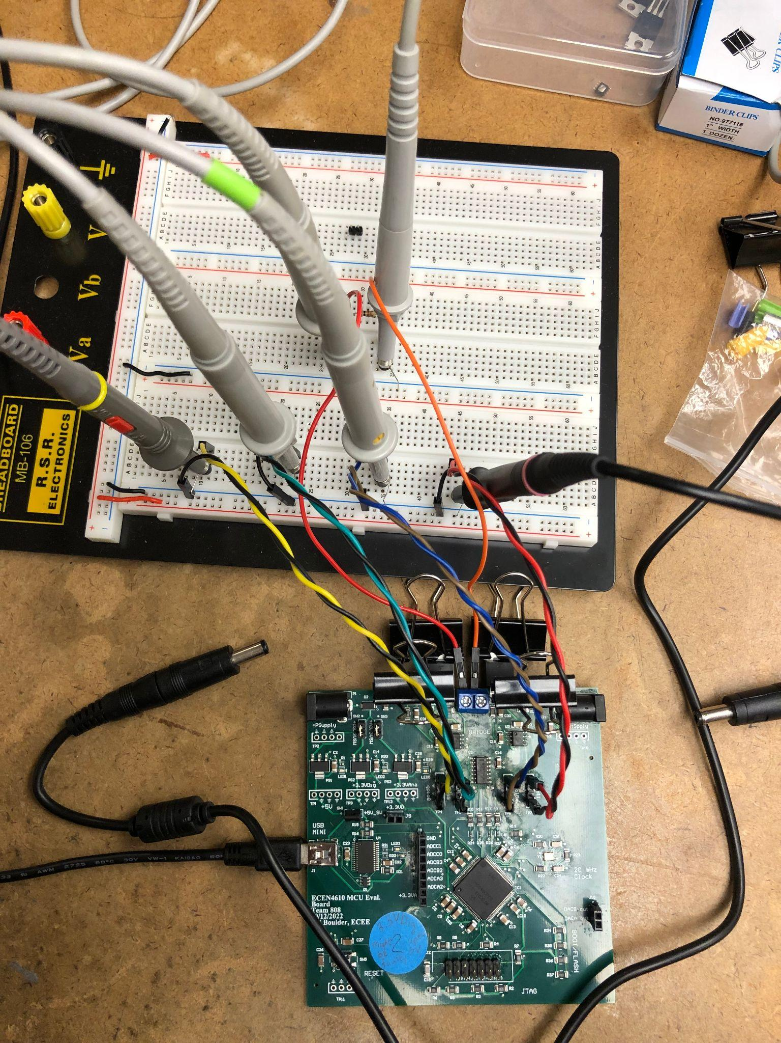

**Figure 5:** The figure above shows the phase-shifted full bridge setup where the 4 PWM signals are broken out onto the breadboard in order to measure them. The phase-shifted full bridge is then connected across a load and the output is measured using two probes.

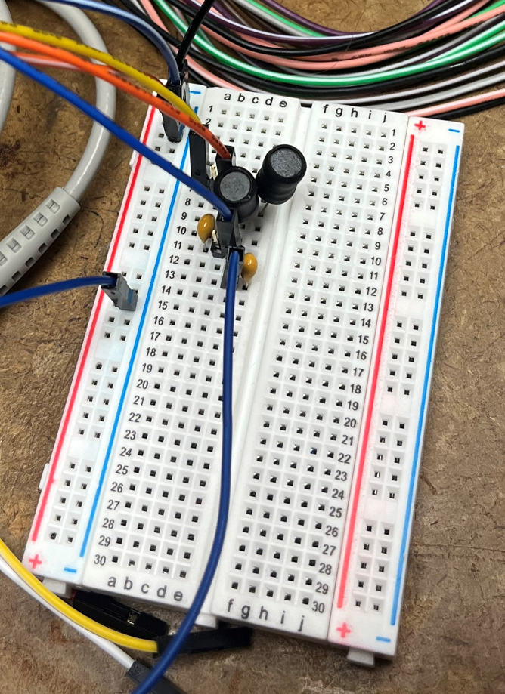

**Figure 6**: Prototype of a resonant tank implemented on a breadboard. The input waveform is from the Analog Discovery 2.



**Figure 7**: Calculations of the resonant tank SBB circuit

**4.5 Phase 2 Design & Proof of Concept Results**

**PWM Synchronization:**

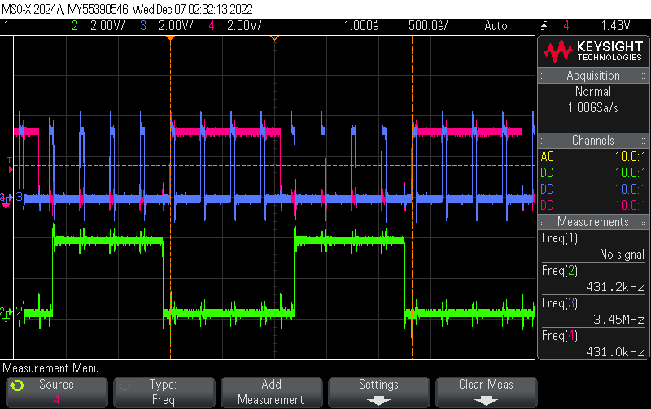

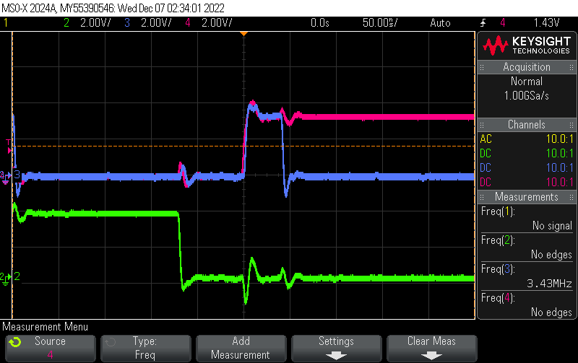

**Figure 8a (top) and 8b (bottom):** PWM Synchronization

The blue trace is the PWM used to start the ADC conversion at 3.45 M samples per second. The pink and green trace is the PWM used to send to the phase controlled full bridge at 431.25kHZ. There will be 8 ADC samples/ pulses per cycle (431.25kHZ). As seen in the above picture, there are 8 blue pulses in 1 green pulse. And every 1st blue trace starts at the same time with the pink pulse.

**Voltage Sensor:**

**Figure 9:** LTSpice schematic of the voltage sensor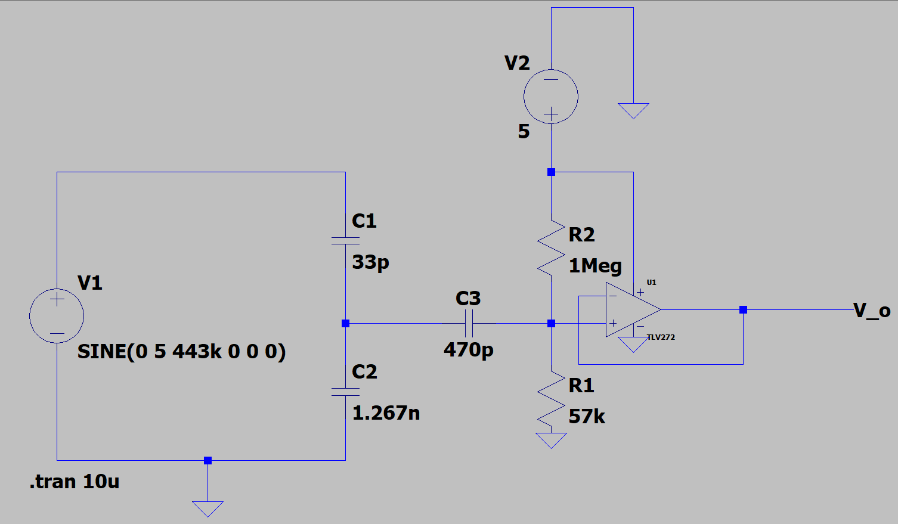

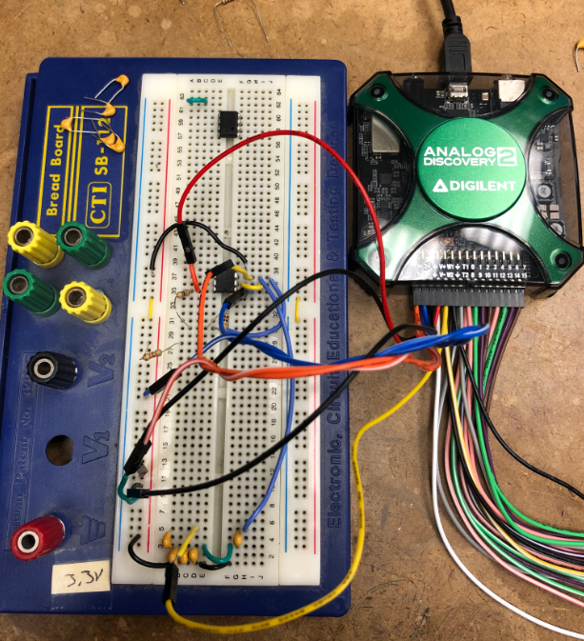

**< Figure 10:** Breadboarded voltage sensor hooked up to the AD2 waveform generator

**^ Figure 11:** Waveforms generated by the AD2 and voltage sensor during testing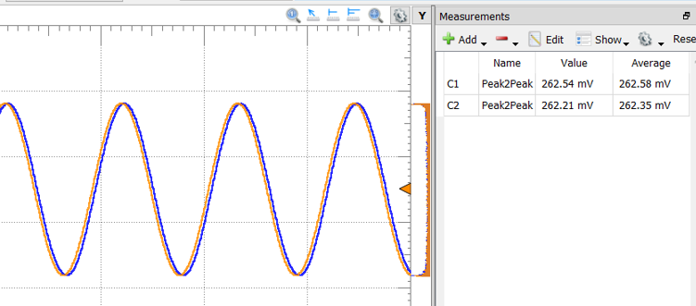

**5 Risk Analysis**

## **5.1 Risk Sites**

### **5.1.1** **Microcontroller**

The microcontroller we are using is part of the TI Piccolo series, specifically the TMS320F280049 (IC MCU 32BIT 64KB FLASH 48LQFP). There is low stock of this as it is not a relatively common microcontroller and there is a chip shortage, but we were able to get 5. However, if we run into issues with these, such as a current spike because of faulty board design rendering them inoperable, it would be a challenge to get more in a timely manner. A design constraint of our project is having a microcontroller with a high sampling speed, and this one meets our requirement of 8 samples per procedure cycle from our system (sampling rate of approximately 3.45 MSPS).

To mitigate the risk, we have selected two alternative microcontrollers to fall back on if the TI Piccolo fails. The first is the Infineon PSOC. It requires knowledge of a different design interface which is risky by itself, but by preemptively learning the software using this chip shouldn’t set our schedule back. It has a lower sampling speed so we would have to work around this by adjusting the way samples are taken and graphed, by taking less samples per cycle but combining them with other samples taken out of phase in concurrent cycles to imitate a higher sampling rate. Another alternative would be to use the Arduino ATMEGA, as this one is easy to use and our group has experience with the software necessary, but this also has the same issue of a lower sampling rate.

### 

### **5.1.2** **Impedance Measurements**

One of the most important functions of the ESU is its ability to take impedance measurements and feed them both back into the microcontroller and out to the user. The microcontroller examines the impedance changes and stops a cauterization cycle when they reach a certain point above the tissue’s initial impedance value. If this is done incorrectly, the tissue will either not be sealed completely or it will overshoot and char the tissue, causing significant damage to the area and requiring further incisions to remove. The data is fed back to the user to examine because it helps the user diagnose any issues that arise during a cycle. The impedance changes should follow a specific curve, shown below, and if they don’t it is valuable for the user to be able to see the exact behavior of the unexpected impedance.

The measurements are taken across the jaws of the connected LigaSure device. Our ESU uses a capacitive voltage divider to measure voltage across and a resistor-based current sensor for current. Impedance will be calculated from these values. Back up plans for taking these measurements are to switch the components used for measuring by using a resistor-based voltage sensor and a capacitive current sensor. If the issue is not with the nature of the components, there are many other values of resistors and capacitors that can replace the ones the ESU is using to get the readings we are looking for.

### **5.1.3** **Resonant Tank Design**

The ESU contains a resonant tank which is responsible for filtering and creating the constant 431 kHz tone required for proper cauterization. Resonant FR tanks are a topic which no members of our group were familiar with, and as such designing this posed a large risk to the product’s efficacy. It must deliver a 115 V peak-to-peak sinusoidal tone, or the tissue load it crosses will either not cauterize consistently or will receive too large of a tone and char.

Our group began the design process on our own but quickly fell back onto our first backup plan, which was to leverage the help of power experts within CU’s electrical engineering department to receive guidance. Our second plan was to purchase an off-the-shelf tank if our design completely failed, but we did not end up needing to do this. The last option posed its own risks, in that even if it circumvented the need to design our own tank, it would be hard to find a pre-existing design which both matches the design constraints inherent to the finished product and also is in stock and ships in a timely manner.

Another risk the resonant tank proposes is the need to wind custom transformers which the team has never done before, and the possibility of specific component values not being readily available for use when implementing the design.

### 

### **5.1.4** **ESU Frame Design**

For the frame which will house our ESU circuitry and interface, a custom plastic 3D print would be ideal. However, none of our group members have experience with CAD. Since the design of this must be adjusted as our project develops, we have plans to fabricate this at the very end of our design process which poses the risk of our team running out of time to learn CAD, design, and print this before EXPO. If we have the time, we will allocate enough to make a frame which is as perfect of a fit as possible.

If time does end up running out, our backup plans are to laser cut parts and make a more simplistic design - one that is not as well suited for our circuitry but will look clean and professional, or repurpose a pre-existing box. The design must remain sturdy, lightweight, and cost-effective. If we laser cut, the box will be plastic as the laser cutters in the ITLL do not handle metal, but a reused box could be either lightweight metal, like aluminum, or plastic.

**5.2 Test Demos**

### **5.2.1** **Microcontroller**

To test the functionality of the TI Piccolo microcontroller, it was necessary to confirm the flash upload as well as the bipolar square wave generation. Meanwhile, the conversion frequency of the ADC is synchronized with the PWM frequency, as 431kHz. And 8 samples per cycle data can be retrieved both from ADC A (voltage sensor’s input) and ADC B (current sensor’s input).

To set up the tests, Infineon PSOC is used. In order to demonstrate Infineon PSOC's viability, it was essential that we confirm the 431kHz square wave is generated by the PWM. In addition, the phase control function needed to be created and verified. Example: PWM 2 is phase shifting to some degrees based on PWM 1. Beyond that, the functionality of ADC needs to be verified as well, for example, the conversion frequency of ADC is synchronized with the PWM frequency, and voltage and current sensor’ input are retrieved from the ADC within the range from 0-3.3V.

### **5.2.2** **Impedance Measurements**

To test the impedance measurements we receive, we ran our system with various resistors with similar values to the tissues our system will operate on—the tissue starts at around 10 ohms and then shoots up to 1000-2000 ohms during cauterization. This allows for us to see if our system is both properly detecting voltage and current as well as if the PI controller is properly recalibrating the values so that our resonance tank is in the correct mode of operation. With a given resistance value, we are able to calculate an expected value for voltage, current, and power. With the expected values in mind, voltage, current, and power can be measured across the load using an oscilloscope and/or multimeter to determine if we are getting the expected outputs.

**5.2.3**  **Resonant Tank Design**

After initial guidance from Dr. Dragan Maksimovic and further self-study calculations of the resonant tank design began. Medtronic required a nominal output voltage of 115 volts at 50 watts. A LCC configuration was chosen for this specific case since it offers the most flexibility when computing component values of the inductors and capacitors. First the open circuit transfer function H∞(S) where R→∞ was computed, which gave insight to how the magnitude of the output voltage depends on the load current. Then using the transfer function the peak voltage at the nominal operating point (163 volts) was computed followed by the peak current at the nominal operating point(0.614 Amps). These computations led to the nominal resistance calculations (264 Ω). Using the peak current at the nominal operating, peak voltage at the nominal operating point, and open circuit voltage values the short circuit current value was calculated which is one of the modes that the impedance characteristic curve follows. After these calculations the impedance of the series and parallel branches of the LCC network were calculated which led to the output impedance given by the series and parallel branches of the LCC network. Using these values the capacitance and inductor values were calculated which were 0.01µF and 12.2mH respectively. It is important to note that since the design process of the resonant tank was conducted the values of the capacitors and inductors can be easily changed with respect to change in specs from medtronic in the case a accommodation is needed.

To test the resonant tank design the AD2 Wavegen will be used in conjunction with the fullbridge output. The resonant tank should be able to filter out the high harmonics of the input square wave given by the fullbridge output. This filtration of the higher harmonics should be able to produce a sinusoidal wave at a constant 431 kHz tone. The sinusoidal wave should then give the highest voltage at the resonance where the inductive and capacitive reactances cancel each other by being 180 degrees apart in phase. Using the AD2 wavegen bode plot and frequency sweep feature, the sinusoidal output should be seen producing the highest voltage output. After filtering the square wave from the LCC tank network the voltage is then going to be increased by the transformer output of the LCC network. The turns ratio should then produce an output voltage of 115 volts.

**5.2.4 Voltage Sensor**

**Risk-site to be addressed:** Our system generates a 115V peak-to-peak bipolar sinusoid across a load intended to be tissue under operation. In order to gather information about the tissue to know when a cycle is complete, we will be measuring the voltage across the load and using it as an input for both of our sensors (current and voltage) and to calculate the impedance of the tissue as it changes throughout the cycle. Here, we will be testing the voltage sensor and follower opamp, because if it is not working we cannot fully test our circuit sensor and impedance calculations.

**Functionality:** Our sensor must be able to read the voltage across the load clamped by the ligature jaws and feed that information back to our ADC, which cannot handle the high voltages of the signal being read. The capacitive divider used in the voltage sensing module would scale down the 115 V peak-to-peak bipolar sinusoid to an approximately 3.3V peak-to-peak bipolar sinusoid to accommodate for the ADC’s voltage range of 0-3.3V. The bipolar sinusoid is then inputted to a level-shifting opamp to create a 0-3.3V unipolar sinusoid. The output from the ADC is what is then used to feed the current sensor and the impedance calculations.

**Justification:** The voltage sensor is a crucial part of our project as it is responsible for half of the closed feedback loop information. We need voltage values so that we can calculate an impedance value. The impedance value will then be used to determine our systems response so without a voltage value, our system cannot operate properly. To be safe, we will be doing initial testing with a 1.15 V peak-to-peak input sinusoid instead of 115 V. We expect a 33 mV peak-to-peak bipolar sinusoid as an output of the capacitive divider instead of 0 - 3.3 V and a 0 - 33 mV peak-to-peak unipolar sinusoidal wave out of the opamp.

**Preconditions Outline:** Our capacitive divider input port will be connected to the AD2. The divider itself will consist of a 1.08 nF and 33 pF capacitor. There will also be a 470 pF capacitor at the output of the divider to prevent any DC leakage from going back into the divider from the opamp. The follower opamp will have resistor values of 1 MΩ and 3.3 kΩ. The output of the sensors will be connected to the follower opamp (unit gain), and the output of the whole circuit will be connected to an oscilloscope.

**Expected Steps Outline:**

* Connect the AD2 waveform generator to the input of our capacitive divider and the oscilloscope to the output of the opamp
* Input a 1.15V peak-to-peak bipolar sinusoidal wave into the voltage sensing circuit
* Add a DC bias of 16.5 mV to the summing junction of our opamp
* Read the output of the circuit on the oscilloscope

**Quantitative Success Criteria:**

* Output from capacitive dividers reads as a -16.5 mV to +16.5 mV sinusoid on the scope
* Output from the opamp is a 0 - 33 mV peak-to-peak unipolar sinusoid

**5.2.5 Synchronized PWM**

**Risk-site to be addressed:** In order to know when a system cycle is complete, we will be measuring the voltage across the load and using it as an input for both of our sensors (current and voltage). Using those measurements, we will calculate the impedance of the tissue/load as it changes throughout the cycle point by point. Here, we will be testing the synchronization of PWM because if it is not working, we cannot get the correct current, voltage, impedance, and point-by-point calculation at the same time as the uC starts to pulse.

**Functionality:** Our synchronized PWM will be sent to the phase controlled full bridge and used to start the conversion of ADC for both the voltage and current reading. Two different frequency PWMs will be used. 431kHZ PWM will be used for the phase controlled full bridge and the RF tank to generate power. 431kHz * 8 = 3.45MHz will be used for the ADC conversion, and 8 samples per cycle will be achieved.

**Justification:** The synchronized PWM is a crucial part of getting accurate measurements from the voltage and current sensors. We need to make sure that the voltage, current, and impedance values are synchronized with the PWM used in the phase controlled full bridge. For example, the voltage, current, and impedance values will be measured when the power is sent to the external Ligasure dissection device. In addition, 8 samples per cycle can’t be achieved if two PWM signals are not synchronized.

**Preconditions Outline:** 431kHZ PWM output will be routed to gpio8 (PIN 38 on board). 3.45MHz PWM output will be routed to gpio0 (PIN 60 on board). The two PWM outputs from the uC will be connected to the oscilloscope. A 431kHZ PWM will be connected to Channel 1. A 3.45MHz PWM will be connected to Channel 2. Both channels will be grounded to the GND.

**Expected Steps Outline:**

* Route the 431kHZ PWM output to gpio8 (PIN 38 on board)
* Route the 3.45MHz PWM output to gpio0 (PIN 60 on board)
* Connect the 431kHZ PWM to Channel 1
* Connect the 3.45MHz PWM to Channel 2
* Trigger the waveform on Channel 1.
* Measure the frequency of the PWM pulses on the oscilloscope
* Count the number of pulses of 3.45MHz PWM in one cycle(431kHz PWM)

**Quantitative Success Criteria:**

* The frequency of two PWMs is ~431kHZ and 3.45MHZ
* Both signals can be triggered by Channel 1. Then, two PWM signals can be synchronized
* 8 PWM pulses from the 3.45MHz PWM are observed in one cycle of 431kHz PWM.

**6 Status of Final Design**

**6.1 What’s Complete**

As of 12/9/22, the PWM phase control, resonant tank, and the phase shifted full bridge sections of the ESU generator have been built and tested. The first iteration of the custom PCB has been developed and fully loaded with all its components, and has been providing successful readings in the testing of the other components of the generator. The PuTTY serial port has also been successfully implemented and is providing readings for other system tests.

**6.2 What’s In Development**

As of 12/9/22, the voltage sensor for the ESU generator is still undergoing design and testing, along with the second iteration of the custom PCB and also the software needed for the microcontroller to intake impedance and adjust the sinusoidal wave output accordingly.

**6.3 What Needs Work**

As of 12/9/22, the current sensor and transformer sections of the ESU generator have not been designed yet. The Python-based GUI, needed for the end user to easily run the cauterization cycles as well as see the collected impedance, voltage, current, and power data from the microcontroller has also not been designed.

# 

# **7 Schedule**

| **Date** | **Development Objective** |
| --- | --- |
| 10/13/22 | Complete Phased-Controlled Full-Bridge simulation (LTSpice) / Send eval. board for manufacturing |
| 10/27/22 | Complete Phased-Controlled Full-Bridge topology prototype / Serial monitoring initiated |
| 11/1/22 | Test evaluation board from Phase 1. Successful prototype generation of PWM gate drive signal using the TI Piccolo uC on custom PCB |
| 11/10/22 | Implement a resonant tank on a breadboard using Analog Discovery 2. Flashed the programmer into the board, compatible for power cycling. |
| 11/16/22 | Tested phase shifted full bridge on custom PCB. Implemented resonant tank prototype with the custom PCB phase shifted full bridge. |
| 11/21/22 | Tested the CLA ( Executed) code independently of main CPU  Test the ADC in CLA. Begun simulations/prototype current/voltage sensing circuit |
| 11/28/22 | Continued the ADC/ Continued simulation/prototype of IV sensors.. Implemented the prototype RF Tank with the I/V sensors. |
| 12/05/22 | Implement the open-loop system. Custom boards #2 sent for fabrication. |
| 1/12/23 | Complete current/voltage sensing circuit prototype |
| 1/26/23 | Complete the digital signal processing module with TI Piccolo uC |
| 2/17/23 | Complete implementation of HLA (TI Piccolo uC) controlling power modulation of RF tone. Constant Power/Constant Voltage/ Constant Current |
| 3/9/23 | Complete Firmware/Software Testing |
| 3/16/23 | Complete Integration Testing |
| 3/23/23 - 4/10/23 | Complete Holistic Device Testing |
| 4/28/23 | Engineering Expo |

# 

# **8 Budget**

**TOTAL COSTS:** $1478.05

**ITEM BREAKDOWN:**

**#1** - Project poster, Manufacturer: ITLL, Unit cost: $80.00, Quantity: 1, Total cost: $80.00

**#2** - Voltera tip, Manufacturer: Voltera, Mft part num: Nozzles-225um, Unit cost: $50.00, Quantity: 1, Shipping cost: $15.00, Total cost: $65.00

**#3** - Development tool, Total cost: $0.00

**#4** - MCU (Piccolo family), Manufacturer: Texas Instruments, Mft part num: F280049CPZS, Unit cost: $0.00 (from MedTronic), Quantity: 5, Total cost: $0.00

**#5** - 48V power supply, Manufacturer: DROK, Unit cost: $39.99, Quantity: 1, Total cost: $39.99

**#6** - Generator Box Materials, Unit cost: $70.00, Quantity: 1, Total cost: $70.00

**#7** - Passive components, Manufacturer: Mouser, Mft part num: misc., Unit cost: $100.00, Quantity: 1, Shipping cost: $10.00, Total cost: $110.00 undetermined

**#8** - Converters, Manufacturer: Texas Instruments, Mft part num: LMR38010FDDAR, Unit cost: $2.30, Quantity: 5, Cost: $11.48, Shipping cost: $10.00, Total cost: $21.48

**#8** - Gate driver, Manufacturer: Digi-Key, Mft part num: LM5101AMR, Unit cost: $3.40, Quantity: 40, Shipping cost: $6.99, Total cost: $124.99

**#9** - PCB, Manufacturer: JLC, Quantity: 10, Total cost: $148.68

**#10 -** Wall power converter, Manufacturer: SoulBay, Quantity: 4, Total cost: $54.64

**#11** - Power MOSFET, Manufacturer: TOSHIBA, Mft part num: TK3R2E06PL,S1X, Unit cost: $1.65, Quantity: 16, Shipping cost: $7.99, Total cost: $34.39

**#12** - Heat sink, Manufacturer: Easy Cargo, Mft part num: ES-TO-220-H10B201511, Unit cost: $7.30, Quantity: 1, Total cost: $7.30

**#13** - PC power cord, Manufacturer: Amazon Basics, Unit cost: $6.94, Quantity: 1, Total cost: $6.94

#**14** - Insulated Fork Spade Wire Connectors (100 pc), Manufacturer: MILAPEAK, Unit cost: $7.89, Quantity: 1, Total cost: $7.89

**#15-** Future PCB Development from JLC: $300.00

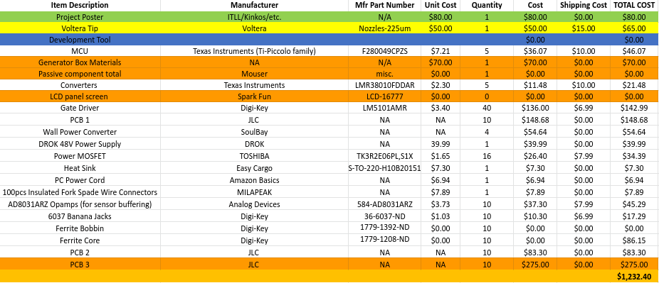

Unit cost, qut, cost, shipping, total